



**Module Code & Module Title**

**CU6051NA - Artificial Intelligence**

**Assignment**

**Naïve Bayes Classifier**

**Year and Semester**

**2018-19 Spring**

**Student Name: Rajat Shrestha**

**London Met ID: 17030954**

**College ID: np01cp4a170021**

**Table of Contents**

Naïve Bayes Classifier Assignment Solution 1

1. Building vocabulary: 2

2. Bag of words approach to build feature vectors: 2

3. Calculating each word in both bags: 4

4. Mapping the words for given text 6

5. Final Calculation: 7

# Naïve Bayes Classifier Assignment Solution

We must calculate and classify the test data by using the labelled training data provided below using the Naïve Bayes Classifier for spam detection.

Training examples consist of text labeled as spam or not spam. Use the examples to build the vocabulary for the classifier. Then using the bag of words approach, transform the texts into feature vectors. Then following the algorithm for the Naïve Bayes Classifier, classify the 2 texts in the test data table as spam or not spam.

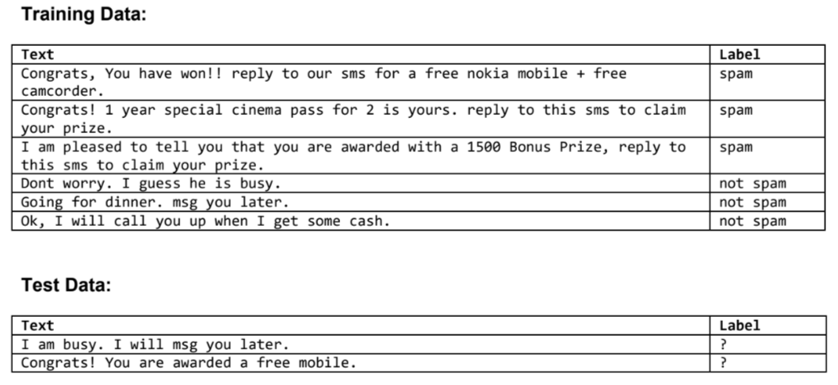

Figure 1: Tables of data

To build a decision tree we must go through various process to find the nodes:

## Building vocabulary:

First, we must fine the overall vocabulary used in both the mails and spams. By filtering out the special characters, punctuations, and numbers then converting all of the words to lowercase we get:

['ok', 'i', 'will', 'call', 'you', 'up', 'when', 'get', 'some', 'cash', 'going', 'for', 'dinner', 'msg', 'later', 'dont', 'worry', 'guess', 'he', 'is', 'busy', 'am', 'pleased', 'to', 'tell', 'that', 'are', 'awarded', 'with', 'a', 'bonus', 'prize', 'reply', 'congrats', 'year', 'special', 'cinema', 'pass', 'yours', 'this', 'sms', 'claim', 'your', 'have', 'won', 'our', 'free', 'nokia', 'mobile', 'camcorder']

This vocabulary can be used to

## Bag of words approach to build feature vectors:

Using the created vocabulary and mapping them out with mails and then spams to calculate the frequency of their occurrence in a table. The first column represents the vocabulary words while the other columns represents each sentence and the tally of the occurrence of the respective word.

Table 1: Bag of words for mails

|  |  |  |  |
| --- | --- | --- | --- |
| **Words** | **1st** | **2nd** | **3rd** |
| ok | 1 | 0 | 0 |
| i | 2 | 0 | 1 |
| will | 1 | 0 | 0 |
| call | 1 | 0 | 0 |
| you | 1 | 1 | 0 |
| up | 1 | 0 | 0 |
| when | 1 | 0 | 0 |
| get | 1 | 0 | 0 |
| some | 1 | 0 | 0 |
| cash | 1 | 0 | 0 |
| going | 0 | 1 | 0 |
| for | 0 | 1 | 0 |
| dinner | 0 | 1 | 0 |
| msg | 0 | 1 | 0 |
| later | 0 | 1 | 0 |
| dont | 0 | 0 | 1 |
| worry | 0 | 0 | 1 |
| guess | 0 | 0 | 1 |
| he | 0 | 0 | 1 |
| is | 0 | 0 | 1 |
| busy | 0 | 0 | 1 |
| am | 0 | 0 | 0 |
| pleased | 0 | 0 | 0 |
| to | 0 | 0 | 0 |
| tell | 0 | 0 | 0 |
| that | 0 | 0 | 0 |
| are | 0 | 0 | 0 |
| awarded | 0 | 0 | 0 |
| with | 0 | 0 | 0 |
| a | 0 | 0 | 0 |
| bonus | 0 | 0 | 0 |
| prize | 0 | 0 | 0 |
| reply | 0 | 0 | 0 |
| congrats | 0 | 0 | 0 |
| year | 0 | 0 | 0 |
| special | 0 | 0 | 0 |
| cinema | 0 | 0 | 0 |
| pass | 0 | 0 | 0 |
| yours | 0 | 0 | 0 |
| this | 0 | 0 | 0 |
| sms | 0 | 0 | 0 |
| claim | 0 | 0 | 0 |
| your | 0 | 0 | 0 |
| have | 0 | 0 | 0 |
| won | 0 | 0 | 0 |
| our | 0 | 0 | 0 |
| free | 0 | 0 | 0 |
| nokia | 0 | 0 | 0 |
| mobile | 0 | 0 | 0 |
| camcorder | 0 | 0 | 0 |

Table 2: Bag of words for spams

|  |  |  |  |
| --- | --- | --- | --- |
| **Words** | **1st** | **2nd** | **3rd** |
| ok | 0 | 0 | 0 |
| i | 1 | 0 | 0 |
| will | 0 | 0 | 0 |
| call | 0 | 0 | 0 |
| you | 2 | 0 | 1 |
| up | 0 | 0 | 0 |
| when | 0 | 0 | 0 |
| get | 0 | 0 | 0 |
| some | 0 | 0 | 0 |
| cash | 0 | 0 | 0 |
| going | 0 | 0 | 0 |
| for | 0 | 1 | 1 |
| dinner | 0 | 0 | 0 |
| msg | 0 | 0 | 0 |
| later | 0 | 0 | 0 |
| dont | 0 | 0 | 0 |
| worry | 0 | 0 | 0 |
| guess | 0 | 0 | 0 |
| he | 0 | 0 | 0 |
| is | 0 | 1 | 0 |
| busy | 0 | 0 | 0 |
| am | 1 | 0 | 0 |
| pleased | 1 | 0 | 0 |
| to | 2 | 2 | 1 |
| tell | 1 | 0 | 0 |
| that | 1 | 0 | 0 |
| are | 1 | 0 | 0 |
| awarded | 1 | 0 | 0 |
| with | 1 | 0 | 0 |
| a | 1 | 0 | 1 |
| bonus | 1 | 0 | 0 |
| prize | 1 | 1 | 0 |
| reply | 1 | 1 | 1 |
| congrats | 0 | 1 | 1 |
| year | 0 | 1 | 0 |
| special | 0 | 1 | 0 |
| cinema | 0 | 1 | 0 |
| pass | 0 | 1 | 0 |
| yours | 0 | 1 | 0 |
| this | 0 | 1 | 0 |
| sms | 0 | 1 | 1 |
| claim | 0 | 1 | 0 |
| your | 0 | 1 | 0 |
| have | 0 | 0 | 1 |
| won | 0 | 0 | 1 |
| our | 0 | 0 | 1 |
| free | 0 | 0 | 2 |
| nokia | 0 | 0 | 1 |
| mobile | 0 | 0 | 1 |
| camcorder | 0 | 0 | 1 |

## **Calculating each word in both bags:**

Calculating the weight for the words found in mails:

0.02702702702702703 ok

0.05405405405405406 i

0.02702702702702703 will

0.02702702702702703 call

0.04054054054054054 you

0.02702702702702703 up

0.02702702702702703 when

0.02702702702702703 get

0.02702702702702703 some

0.02702702702702703 cash

0.02702702702702703 going

0.02702702702702703 for

0.02702702702702703 dinner

0.02702702702702703 msg

0.02702702702702703 later

0.02702702702702703 dont

0.02702702702702703 worry

0.02702702702702703 guess

0.02702702702702703 he

0.02702702702702703 is

0.02702702702702703 busy

0.013513513513513514 am

0.013513513513513514 pleased

0.013513513513513514 to

0.013513513513513514 tell

0.013513513513513514 that

0.013513513513513514 are

0.013513513513513514 awarded

0.013513513513513514 with

0.013513513513513514 a

0.013513513513513514 bonus

0.013513513513513514 prize

0.013513513513513514 reply

0.013513513513513514 congrats

0.013513513513513514 year

0.013513513513513514 special

0.013513513513513514 cinema

0.013513513513513514 pass

0.013513513513513514 yours

0.013513513513513514 this

0.013513513513513514 sms

0.013513513513513514 claim

0.013513513513513514 your

0.013513513513513514 have

0.013513513513513514 won

0.013513513513513514 our

0.013513513513513514 free

0.013513513513513514 nokia

0.013513513513513514 mobile

0.013513513513513514 camcorder

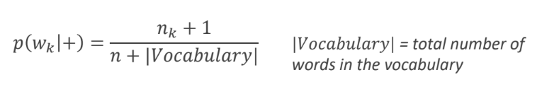

Calculating the weight for the words found in spams:

0.010309278350515464 ok

0.020618556701030927 i

0.010309278350515464 will

0.010309278350515464 call

0.041237113402061855 you

0.010309278350515464 up

0.010309278350515464 when

0.010309278350515464 get

0.010309278350515464 some

0.010309278350515464 cash

0.010309278350515464 going

0.030927835051546393 for

0.010309278350515464 dinner

0.010309278350515464 msg

0.010309278350515464 later

0.010309278350515464 dont

0.010309278350515464 worry

0.010309278350515464 guess

0.010309278350515464 he

0.020618556701030927 is

0.010309278350515464 busy

0.020618556701030927 am

0.020618556701030927 pleased

0.061855670103092786 to

0.020618556701030927 tell

0.020618556701030927 that

0.020618556701030927 are

0.020618556701030927 awarded

0.020618556701030927 with

0.030927835051546393 a

0.020618556701030927 bonus

0.030927835051546393 prize

0.041237113402061855 reply

0.030927835051546393 congrats

0.020618556701030927 year

0.020618556701030927 special

0.020618556701030927 cinema

0.020618556701030927 pass

0.020618556701030927 yours

0.020618556701030927 this

0.030927835051546393 sms

0.020618556701030927 claim

0.020618556701030927 your

0.020618556701030927 have

0.020618556701030927 won

0.020618556701030927 our

0.030927835051546393 free

0.020618556701030927 nokia

0.020618556701030927 mobile

0.020618556701030927 camcorder

## Mapping the words for given text

**Text = 'I am busy. I will msg you later.'**

First with weights calculated from mails

i 0.05405405405405406

am 0.013513513513513514

busy 0.02702702702702703

i 0.05405405405405406

will 0.02702702702702703

msg 0.02702702702702703

you 0.04054054054054054

later 0.02702702702702703

Then with weights calculated from spams

i 0.020618556701030927

am 0.020618556701030927

busy 0.010309278350515464

i 0.020618556701030927

will 0.010309278350515464

msg 0.010309278350515464

you 0.041237113402061855

later 0.010309278350515464

**Text = 'Congrats! You are awarded a free mobile.'**

First with weights calculated from mails

congrats 0.013513513513513514

you 0.04054054054054054

are 0.013513513513513514

awarded 0.013513513513513514

a 0.013513513513513514

free 0.013513513513513514

mobile 0.013513513513513514

Then with weights calculated from spams

congrats 0.030927835051546393

you 0.041237113402061855

are 0.020618556701030927

awarded 0.020618556701030927

a 0.030927835051546393

free 0.030927835051546393

mobile 0.020618556701030927

## Final Calculation:

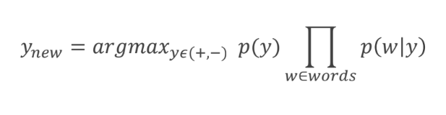

Figure 2: Formula for classifying

Multiplying the mapped value with their respective probabilities (using the above formula).

**Text = 'I am busy. I will msg you later.'**

Probability of being a mail P(M) = 4.2704876133169763e-13

Probability of being spam P(S) = 2.041484601729748e-15

As P(M) > P(S) it is a mail

**Text = 'Congrats! You are awarded a free mobile.'**

Probability of being a mail = 1.2344378257244386e-13

Probability of being spam = 5.34664817193021e-12

As P(M) < P(S) it is a spam

The link to the notebook used to calculate the values:

<https://colab.research.google.com/drive/1uu4Cg6nLlRnKLM2MjalOZ0jpOoKBPrKo>